FIRST robotics

team 2408

2018-2019 Handbook

Table of Contents
Team Overview 4
About FIRST 4
FIRST Tech Challenge 4
FIRST Robotics Competition 5
Examples of FTC Robots 5
Examples of FRC Robots 5
Team Mission Statement 6
Team History 6
FTC Awards 6
FRC Awards 7
Internet Resources 8
Team website 8
Team E-mail address 8
Team Facebook page 8
Member Requirements 9
$50.00 Registration Fee 9
Student Expectations 9
Student Eligibility 10
Safety 10
Attendance Policy 11
Team Structure 12
Coach and Mentors 12
Team Departments 13
Mechanical Department 13
Software Department 13
Public Relations 13
Student Leadership Positions 14
Team President 14
Chief Mechanical Engineer (CME) 14
Chief Software Engineer (CSE) 14
Public Relations and Business Director (PR Director) 14
Non-Enumerated Leadership Positions 15
Financial Information 15
Sponsorship 15
Sponsorship Tiers 15
Travel Policy 16
Student Eligibility to Travel 16
Volunteerism 16
Varsity Lettering 17
Season Calendar 18

Team Overview
Hazelwood West High School's FIRST Robotics Team, registered and identified as number 2408, is known as the Shrapnel Sergeants. Team 2408 is a student-lead group of adults and students committed to the promotion of science, technology, engineering and math, or STEM concepts in our local community. Under the guidance of real world engineers as adult mentors, students construct complex competition robots of various sizes. A multitude of skills essential to a career in engineering are utilized, such as the design process, programming under Java and LABView, documentation, public relations, and even business & management.

About FIRST
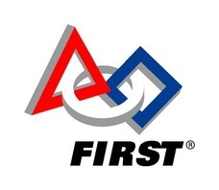
FIRST, which abbreviates "For Inspiration and Recognition of Science & Technology," is a global program with the motive of inspiring the youth of the world to pursue future careers in science and technology. This is achieved through engaging students in exciting mentor-based programs that build STEM (Science, Technology, Engineering, & Math) skills, as well foster well-rounded life capabilities including self-confidence, communication, and leadership.
Team 2408 participates in two FIRST programs: the FIRST Tech Challenge, or FTC, and the FIRST Robotics Competition, or FRC. FTC begins in the fall and competes the following winter, and FRC begins shortly after New Year's Day and competes in the following spring. For more information about the competitions, see the bottom of this page and the following page.

FIRST Tech Challenge
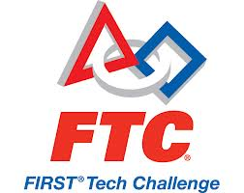
The robotics build season kicks off with the FIRST Tech Challenge, or FTC, each September. Students use TETRIX Aluminum robotics kits as a basis to construct 18-inch cubed robots. Each year, a new game or challenge is announced that all teams must try to satisfy and compete within.

FIRST Robotics Competition
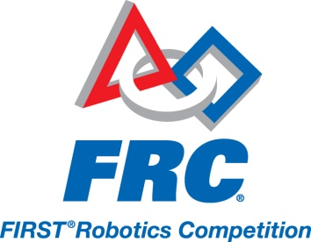
The FRC build season kicks off each January and represents the highest level of FIRST competition. After kickoff, teams are given a strict timeframe of only 6 weeks to complete their robot before it must be bagged & tagged. After the "stop build day," robots cannot be touched again until competition begins. In those short 6 weeks, students must design, build, program, and test a fully-functional competition robot.
FRC robots are typically around 120 pounds, and can potentially be as complex as a small automobile, if not more complex. Every year, there is a new challenge or game for teams to compete against in, and this is announced at kickoff each season, as well as the contents of the current season's Kit of Parts and other promotions.
The entire team must collaborate throughout the season to secure the funds necessary for optimum success each FRC and FTC season. This includes the costs related to the FRC Kit of Parts, competition fees, robot parts and repairs, and potential travel expenses as well as outreach programs.

Examples of FTC Robots
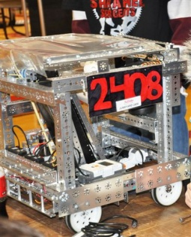
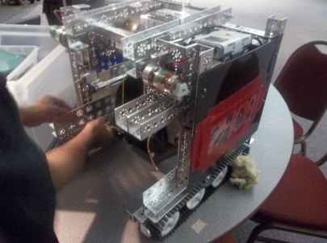
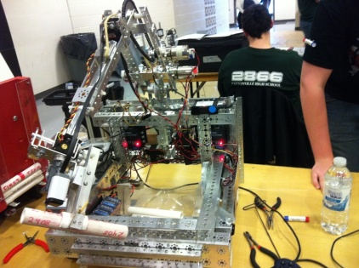

Examples of FRC Robots
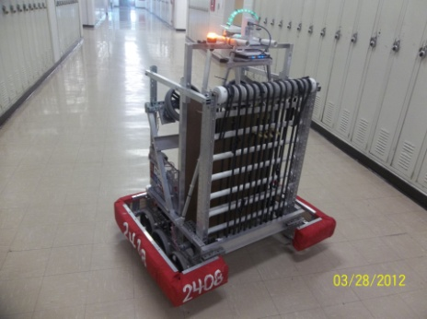
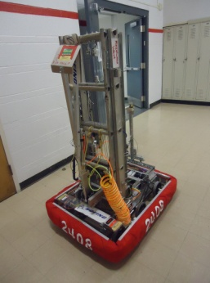
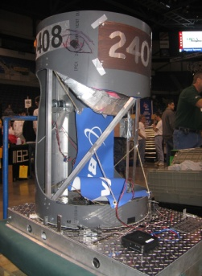

Team Mission Statement
The mission of the Shrapnel Sergeants is to broaden young people's understanding of science, technology, mathematics, and engineering concepts, as well as introduce them to potential career paths in related fields. The team provides opportunities for students to develop team-building and leadership skills.

Team History
The Shrapnel Sergeants were founded in 2007 and originally competed in the BotBall tournament in their first year, alongside FTC & FRC. The original team was composed of approximately 7 students. Today, the team currently has many more registered members, and retains better member continuity between seasons. The Team has attended the FIRST World Championships three times as competitors, and has had individual recognitions at 2 additional FIRST World Championships.
Below is a list of our awards as of the 2014-2015 season.

FTC Awards
Season | Award | Event | Location
2009-2010 | Winning Alliance | St. Louis Qualifier | St. Louis, MO
2009-2010 | Winning Alliance | Southeast MO Qualifier | Cape Girardeau, MO
2009-2010 | Participated in FIRST World Championship
2010-2011 | Think Award | St. Louis Qualifier | St. Louis, MO
2010-2011 | Inspire Award | Missouri State Championship | Rolla, MO
2010-2011 | Participated in FIRST World Championship
2012-2013 | Think Award | St. Louis Qualifier | St. Louis, MO
2012-2013 | Winning Alliance (Red Division) | Southeast MO Qualifier | Cape Girardeau, MO
2012-2013 | Finalist Alliance | Southeast MO Qualifier | Cape Girardeau, MO
2014-2015 | FTC Dean’s List Award Finalist (Mashroor Rashid) | Missouri State Championship | Rolla, MO
2014-2015 | FTC Dean’s List Award Winner (Mashroor Rashid) | FIRST World Championship – Einstein Field | St. Louis, MO

FRC Awards
Season | Award | Event | Location
2010-2011 | Gracious Professionalism Award | St. Louis Regional | St. Louis, MO
2012-2013 | Winning Alliance | St. Louis Regional | St. Louis, MO
2012-2013 | Participated in FIRST World Championship
2013-2014 | Gracious Professionalism Award | St. Louis Regional | St. Louis, MO
2013-2014 | Woodie Flowers Award Finalist (Tom Wendel) | St. Louis Regional | St. Louis, MO
2014-2015 | FRC Dean’s List Award Finalist (Mashroor Rashid) | St. Louis Regional | St. Louis, MO

Internet Resources
Team 2408 is available on many corners of the internet. Namely, the team maintains a website and a Facebook page, both of which are operated by students.

Team website
The team website can be found at www.team2408.weebly.com. It is the online "face" of the team and is primarily used as a public relations outlet.

Team E-mail address
The team's official e-mail address is 2408robots@gmail.com. This is a student-operated email that is mainly used in case an outside group wishes to contact the team for questions and such. You can also contact our coach, Mr. Herman at kherman@hazelwoodschools.org.

Team Facebook page
The team has a Facebook page, located at www.facebook.com/team2408. This is primarily used to notify all team members of meetings or if anything unexpected occurs. All team members that use Facebook on a regular basis are expected to follow the page.

Member Requirements
In this section, the expectations of all team members shall be enumerated.

$60.00 Registration Fee
All team members are required to pay a non-refundable fee of fifty dollars to claim membership on the robotics team. This pays for their team shirt and the rest of the money goes into the team's account for fundraising. For team members with siblings, the other member of the family will only need to pay $25 to the team. Note: Checks are not accepted. This is a policy of Hazelwood West.
Once a member is paid, the following is ensured: A team shirt, official inclusion in the team roster, and online registration for the team on FIRST STIMS.

Student Expectations
- Students will display Gracious Professionalism, a core FIRST value, at all times.
- Students will follow all rules as dictated by Hazelwood West High School.
- Students are expected to communicate and behave courteously and as a team. Should interpersonal problems arise, students will attempt to deal with it maturely; if there is no success then the coach should become involved.
- Students in a relationship should keep these matters outside of the team, and public displays of affection are not permitted.
- All students with Cellphones or emails are expected to sign up with our Remind 101. Students will be notified about important dates, deadlines, and information.
- Students will respect and return all tools and equipment used by the team as well as keep work areas organized and clean at the end of each meeting.
- Students visiting or working at corporate sites must be courteous, respectful, and mindful of rules and expectations at those sites.
- Students who observe fellow team members not adhering to the rules above in a consistent or otherwise detrimental manner have the responsibility to inform the team captain and try to resolve the issue. If this fails, the coach will intervene.

Student Eligibility
- Students must keep their grades up. The team coach has the right to temporarily suspend any team members in order to bring their grades back up before they can participate again. The expectation is a minimum of a 2.5 Grade Point Average.
- Robotics is a significant time commitment, and students are expected to comply with this accordingly. Students must be willing to actively participate in team meetings, events, and community service events when possible.
- Students are expected to be reliable, on-time, and prepared to work.
- Students and parents must complete the necessary paperwork, pay the required fee, and register online when instructed.
- Students will complete 15 hours of community service through FIRST Team 2408. These hours can also be counted towards the Hazelwood West High School graduation requirement.

Safety
Because of the nature of the work of a robotics team, team members must act in a safe manner AT ALL TIMES. This includes any team-related activity at meetings, at events, during competitions, and even during travel.
- Team members will be respectful of any adults or officials promoting safe practices and adhere to their requests.
- Team members must wear safety glasses when working on or near the robot or being in the presence power tools. While there is a community pool of used glasses, it is highly recommended that team members purchase their own pair of safety glasses.
- At competitions, safety glasses must be worn at all times.
- Horseplay is not tolerated. It's okay to have fun, but not in a dangerous manner.
- All work areas must be cleaned up at the end of each meeting, including sweeping the floors and cleaning work surfaces, putting away tools, and disposing of trash.
- Students that are not busy should not socialize or linger in or close to the work environment in a distracting manner.

Attendance Policy
On the robotics team, attendance is taken very seriously. The nature of the activity is very fast-paced and active, so it is important to show up every day and be productive, especially to be considered for special positions such as a driver or department leader. If a team member's absences are frequent and unexcused, they may be considered for suspension or expulsion, courtesy of the team coach. Students with good attendance are rewarded with membership, active roles in leadership, and competition travel.
Excused absences may fall under but are not limited to the following: A prior commitment, a personal or family matter, a very time-consuming school project (subject to review), and so on.
"Homework" is not an excused absence--there are resources and time available to complete homework at the beginning of robotics meetings if necessary, where members can participate in robotics activities after they finish their assignments.

Team Structure
In this section, the organization and structure of the team will be described, including the responsibilities of team leaders.

Coach and Mentors
The team coach is the school contact; a teacher at Hazelwood West High School who is responsible for managing the team and cooperating with the requests of the team members.
Coaches as of January 2018:
- Steve Schlarman (sschlarman@hazelwoodschools.org)
- Jonathan Gunasingham (jgunasingham@hazlewoodschools.org)
Mentors are adult contacts, typically actual engineers from companies like Boeing or IBM, that come in to help the team and provide guidance whenever possible.
Mentors as of January 2019:
- Thomas Wendel, Boeing
- Stephanie Roberts, Boeing
- Jimmy Havilant, Boeing
- Joshua Kupka, FIRST Alumni

Team Departments
The robotics team is composed of three primary "departments," or sectors of business: Mechanical, Software, and Public Relations. All three of these departments work together to ensure that the team is meeting its full potential. Each department has its own chief or student leader.

Mechanical Department
The mechanical side of our team is the largest in size and is responsible for the physical fabrication & maintenance of our competition robots. Team members actively use power tools and mechanical applications to design and build FTC & FRC robots. The mechanical department also comprises of electrical applications, such as wiring and circuitry, and pneumatic (Air powered) devices/applications.

Software Department
The software portion of our team is essentially the conglomerate of programmers. They are responsible for bringing our robots to life through dynamic & documented coding in Java and LABView. They spend a majority of their time creating & maintaining code, as well as testing our robots on practice fields to ensure that they run as planned. Software also includes CAD, or Computer-Aided Design.

Public Relations & Business
The public relations (PR) group of our team deals with a myriad of media, including fundraising, video, photography, responsibility of the engineering notebooks, and FRC award submissions. They are a small, flexible group, and all of our PR members are also active in the mechanical or software department when they aren't occupied with PR work. The PR department is also responsible for keeping the handbook up-to-date with every new season, as well as the team website.

Student Leadership Positions
Specific roles for student leaders have been defined in order to maximize cooperation and promote leadership skills among students in the team. Student leaders are selected at the end of the season, typically in May, in a joint conversation between the current team leaders and the team coach.

Team President
The Team President organizes and directs the team at all times. They will act as a liaison between the students and the team coach to ensure that day-to-day operations are smooth. They will also work with the coach and PR Director to plan/coordinate many team functions. The team president should be a student with the most experience in leadership and should have had experience in most, if not, all three of the team departments. They should be mechanically proficient, able to understand the basics of software, and have a very solid understanding of FIRST robotics including its core dynamics, structure, culture, and competitions. The Team president for the 2018-2019 season is Jennifer Tenholder.

Chief Mechanical Engineer (CME)
The Chief Mechanical Engineer is the head of the mechanical department of the team. A mechanical chief should be the most mechanically proficient team member with experience to back it up as well as attention to detail. The CME, in cooperation with the team president and other department heads, oversees the mechanical and electrical side of the team and keeps it in "check" to make sure that the build season goes by smoothly and efficiently. The Chief Mechanical Engineer for the 2018-2019 season is Robert Buckner.

Chief Software Engineer (CSE)
The Chief Software Engineer is the head of the software department of the team. A senior programmer should be the most programming-proficient team member with experience to back it up. The CSE should have a very solid understanding of not only the language(s) that we utilize, but programming and its dynamics in general. Like the CME, they cooperate with the team captain and other department heads to make sure that the robots and their functional output is top-notch. The Chief Software Engineer for the 2018-2019 season is Meagan Murray.

Public Relations and Business Director (PR Director)
The Public Relations and Business Director is the head of all functions that involve community outreach, volunteering, and media for the team. The PR Director will be actively looking out for volunteering opportunities, sponsorships, overseeing engineering notebooks, creating media (Artwork, logos, brochures etc.) and maintaining our online presence (Social media, website, etc.). The PR Director should work with the Team President and Coach to decide dates for all interactions, as well as overall budgeting for the year. The Public Relations and Business Director for the 2018-2019 season is Benjamin Mahurin.

Non-Enumerated Leadership Positions
There are a number of satellite leadership positions that are not listed here because of their changing nature and/or the fact that they are only important in certain situations or at competition. This includes but is not limited to: Pit Captain, FTC Captain, Safety Captain, Scouting Captain, and Electrical Chief. These will be assigned at the appropriate time of the year to those students who are most fit for that position.

Financial Information
In this section, the structure of the team's financial system is outlined including sponsorship and sponsorship tiers.

Sponsorship
Organizations and individuals that choose to donate money or resources to the team are known as sponsors. As a non-profit organization, the team relies on sponsors. Our principal sponsor is The Boeing Company. To find out more about how to sponsor our team, please contact our team coach (sschlarman@hazelwoodschools.org) or consult the team's business plan document.

Sponsorship Tiers
Below is the structure of our sponsorship system along with the tiers of benefits.
Diamond Sponsor - $5000+
- Robot: Logo size of your choosing on the FRC and FTC robot’s chassis
- Banner: Logo size of your choosing displayed on the team banner
- Website: Logo displayed on the front page and logo and description on the sponsorship page
- Team shirts: Logo size of your choosing on the back of shirts (shirts are worn at competitions and all public events)
- Memorabilia: Thank you plaque and team shirt and/or jersey

Platinum Sponsor - $3000 - $4999
- Robot: Medium-sized logo (approximately 4” x 6”) on the FRC and FTC robots chassis
- Banner: Medium-sized logo displayed on the team banner
- Website: Logo and description on the sponsorship page
- Team shirts: Medium-sized logo on the back of shirts (shirts are worn at competitions and all public events)
- Memorabilia: Thank you plaque and team shirt and/or jersey

Gold Sponsor - $1000 - $2999
- Robot: Small logo (approximately 3” x 4”) on the FRC and FTC robots chassis
- Banner: Small logo displayed on the team banner
- Website: Logo and description on the sponsorship page
- Team shirts: Small logo on the back of shirts (shirts are worn at competitions and all public events)
- Memorabilia: Thank you plaque and team shirt and/or jersey

Silver Sponsor - $100 - $999
- Robot: Business card-sized logo (approximately 2” x 3.5”) on the FRC and FTC robots chassis
- Banner: Business card sized logo displayed on the team banner
- Website: Logo and description on the sponsorship page
- Team shirts: A line of text on the back of shirts (shirts are worn at competitions and all public events)
- Memorabilia: Thank you card and team shirt

Bronze Sponsor - $25 - $99
- Team shirts: A line of text on the back of shirts (shirts are worn at competitions and all public events)
- Memorabilia: Thank you card

Available to all Sponsors:
- Members of the team will give a complimentary presentation providing more information/interactive demonstration with robot.
- Invitation to the teams end of the year celebratory banquet

Travel Policy
Several times a year, the team participates in out-of-town events/competitions for FTC and FRC. These trips are thoroughly planned in advance, and often involve staying at a hotel overnight as well as traditional restaurant dinners after competition. During these trips, safety is the highest priority and team parents, mentors, and the coach cooperate to ensure that everything runs smoothly.

Student Eligibility to Travel
Out-of-town events are very enjoyable and a great learning experience, but due to their nature, they are to be considered a reward for members of the team that are productive and actively contribute. The following three factors will be considered in deciding whether or not a student is eligible to travel: Attendance, grades, and general recommendations from adults and team leaders.

Volunteerism
Throughout the year, it is not uncommon at all for the team to volunteer at various community events. These are not limited to robotics-only events. All activities can count towards the graduation requirement for community service hours. Last year the team volunteered at elementary school competitions, the St. Louis Area Food Bank, park clean ups in Forest Park and St. Charles, and more. Volunteering is required by all members. Team members should have at least 15 Hours of community service and outreach by the end of the season. These are great bonding experiences among the team members and promote cooperation and a respect for the community.

Varsity Lettering
Staring in the 2015-2016 Season, the Shrapnel Sergeants have adopted FIRST Robotics as a Varsity Sport. Students who wish to achieve Varsity status should:
- Actively participate in the build season.
- Have 25 Hours of Community Service/ Outreach Events.
- Have attended all competitions.
- Have a 2.75 GPA.
Upon completing the requirements above, completing a season of FTC and FRC (1st Year) will qualify for Junior Varsity Status. After the student completes their second year of robotics (FTC and FRC), the student will achieve Varsity Status. With each year on the Varsity team (2+ years), the student will be given a pin for every season they complete afterwards.
Note: Only freshman 1st years will be able to receive Graduating Year Numerals.
Years of Participation | Incentive
1 Year (Junior Varsity) | Graduating Year Numerals (Freshman Only)
2 Years (Varsity) | Varsity Letter + 1st Year Varsity Numeral Pin
3 Years (Varsity) | 2nd Year Varsity Numeral Pin
4 Years (Varsity) | 3rd Year Varsity Numeral Pin

Season Calendar
Below is a prospective look on how the typical season runs, month-by-month.
Month | Events
August | - First meeting and new member recruitment begins  - Preparations for FTC Kickoff
September | - FTC season begins  - Brainstorm FTC robot, begin building
October | - FTC build season  - Volunteer at FLL Qualifiers
November | - FTC build season  - Prepare for first FTC qualifier
December | - First FTC competition at STLCC  - Prepare for FRC Kickoff
January | - FRC 6-week build season begins  - January-March is the busiest period of the whole season  - Meeting almost every day of the week plus weekends  - Second FTC qualifier
February | - Core of the FRC build season  - Still meeting very often  - FRC Award submissions are due
March | - Prepare for FRC competition  - Attend the first FRC regional  - Attend second FRC regional
April | - Attend FIRST World Championship (if qualified)  - Participate in volunteering events
May | - Prepare for next season; select next team leaders  - End of the year celebration and thank-you's
June and July | - Off-season  - Side projects and robot repairs, fine-tuning  - Team bonding activities

